LINUX PROGRAMMING : ASSIGNMENT-2
Name : Eshani Shetty
USN : ENG24CY0020
Roll NO : 04
3rd Sem- Sec ’ B’

1. What does the command pwd, whoami, and hostname display?
1. pwd (Print Working Directory)
- Displays: The current working directory you are in.
- Example:
- $ pwd
- /home/username/Documents
- Use: Helps you know where you are in the filesystem.
2. whoami
- Displays: The username of the current user.
- Example:
- $ whoami
- eshani
- Use: Useful to check which user you are logged in as, especially when switching users.
3. hostname
- Displays: The name of the computer (host) on the network.
- Example:
- $ hostname
- my-laptop
- Use: Identifies the system on a network, useful in networking and remote access.
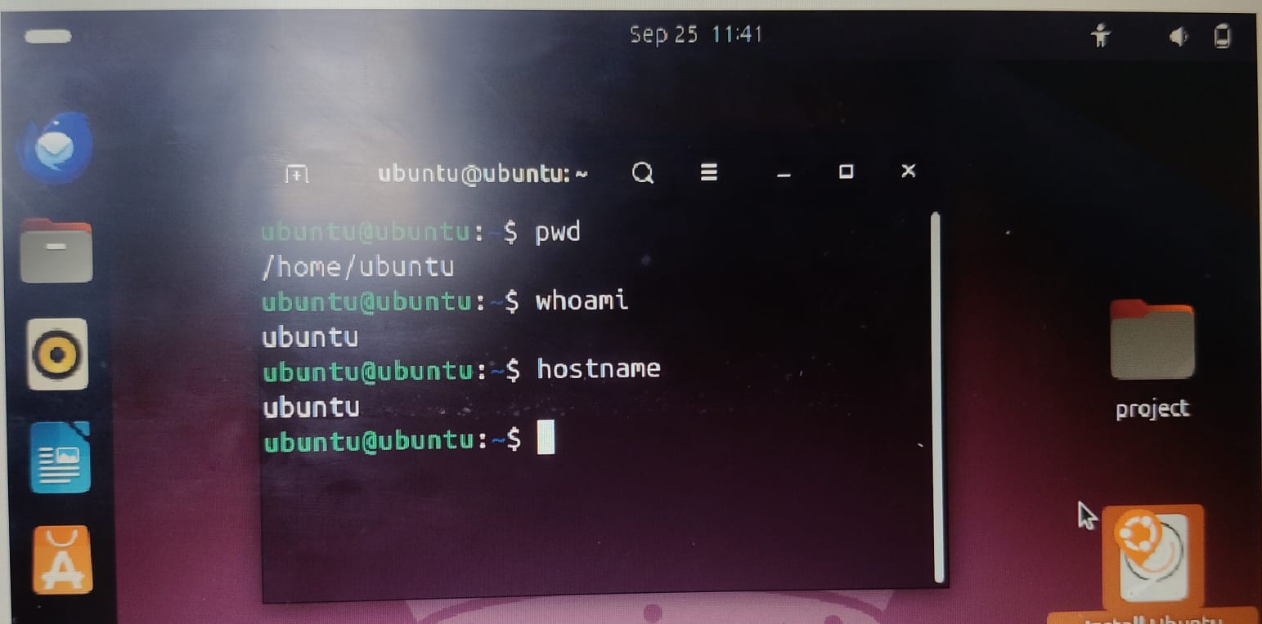

3. Explain the difference between absolute path and relative path with proper
examples.
Absolute Path
- An absolute path gives the complete location of a file or directory starting from the root directory (in Linux/Unix /, in Windows the drive letter like C:\).
- It always points to the same location, no matter where you currently are.
- Linux/Unix:
- /home/ubuntu/documents/report.docx
(Here / is the root directory, then home → ubuntu → documents → report.docx.)
Relative Path
- A relative path describes the location of a file relative to the current working directory (CWD).
- It changes meaning depending on where you are in the directory structure.
Examples:
Suppose your current directory is /home/ubuntu/
- Relative path to report.docx inside documents:
- documents/report.docx
- To go up one directory and then access a file:
- ../mary/notes.txt
(Here .. means "parent directory.")
4. What command will give you the already executed command traces in the terminal. Give output snapshot.
In Linux/Unix, the command is:
history
This shows a numbered list of all commands you have executed in the terminal session. 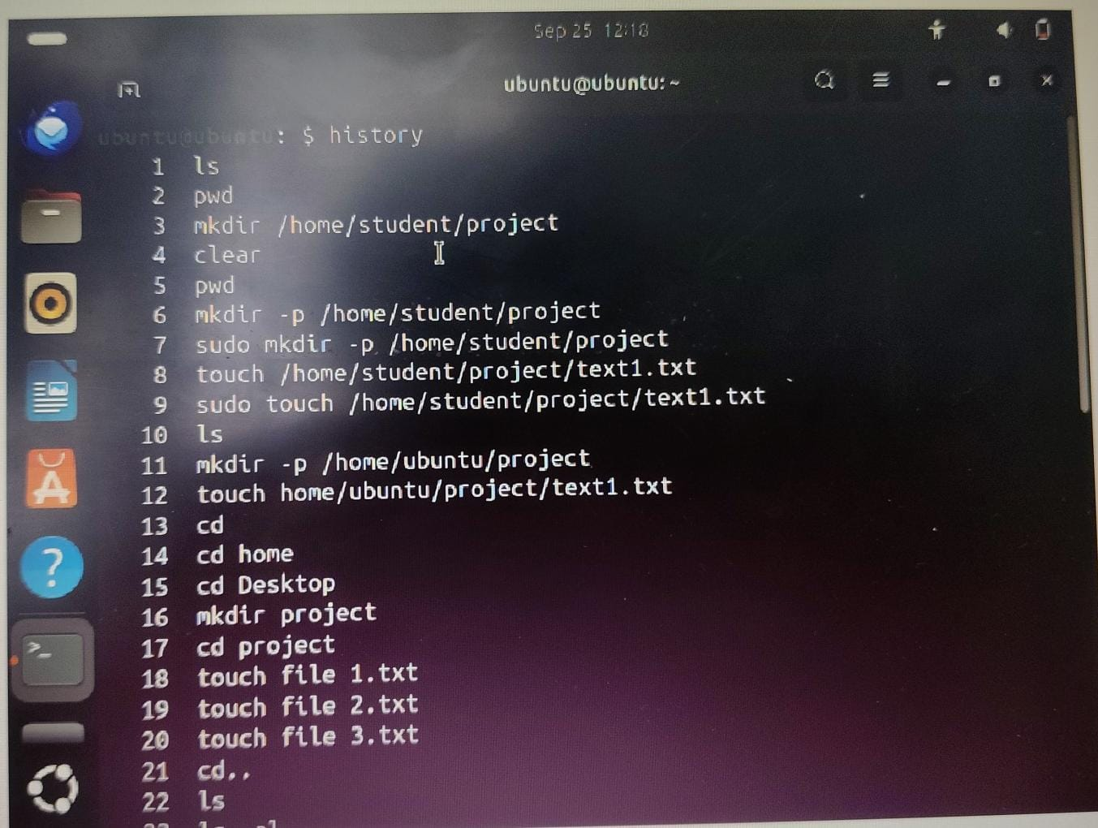
5. Compare the working functionality of find and locate command. Which one is faster and why?
🔹 find command
- Functionality: Searches for files and directories by scanning the real filesystem.
- Syntax:
- find /path -name filename
- Example:
- find /home -name report.txt
→ This will search through /home and all subdirectories until it finds report.txt.
- Pros:
  - Always accurate (because it looks at the actual current filesystem).
  - Can search by many criteria (name, size, modification time, permissions, etc.).
- Cons:
  - Slower, since it scans the filesystem in real-time.
🔹 locate command
- Functionality: Searches files using a prebuilt database (mlocate.db or locate.db) that is updated periodically (usually by updatedb).
- Syntax:
- locate filename
- Example:
- locate report.txt
→ Instantly shows all paths containing report.txt.
- Pros:
  - Much faster, because it just queries a database instead of scanning the disk.
- Cons:
  - Might not be up to date if the database hasn’t been refreshed (sudo updatedb).
- locate is faster
  - Because it uses a pre-indexed database instead of traversing the filesystem in real-time.
- find is slower
  - Because it must search the directory tree live, checking each file and folder.
6. Which command is used to modify file permissions in Linux? Give an example.
The command used to modify file permissions in Linux is chmod (change mode).
Syntax:
chmod [permissions] filename
Eg: chmod g+w report.txt
7. A file has permissions -rw -r- -r- -. What does this mean?
- First character (-) → type of file
  - - = regular file
  - d = directory
  - l = symbolic link
- Next 9 characters (split into 3 groups):
  - rw- (owner) → Owner can read (r) and write (w), but not execute (-).
  - r-- (group) → Group can only read.
  - r-- (others) → Others can only read.
8. Explain the difference between chown and chgrp with an example.
chown (change owner)
- Used to change the ownership of a file or directory.
- A file has an owner (user) and a group.
- Syntax:
- chown newowner filename
Example:
chown alice report.txt
Changes the owner of report.txt to user alice.

chgrp (change group)
- Used to change the group ownership of a file or directory.
- Syntax:
- chgrp newgroup filename
Example:
chgrp developers report.txt
Changes the group of report.txt to developers.
9. A file needs to be accessible by multiple users but only writable by the owner. How will you set permissions?
- Permissions required:
  - Owner → read & write (rw-)
  - Group → read only (r--)
  - Others → read only (r--)
- Permission string:
-rw-r--r--
- Command (numeric):
chmod 644 filename
- Command (symbolic):
chmod u=rw,go=r filename
10. How do you check the manual page for any Linux commands?
To check the manual (help) page for any Linux command, use the man command.
Syntax:
man command_name
2. Write the command to create a directory named “project” inside the
/home/student folder and keep three .txt file into it. Give output snapshot.
- Create the directory:
mkdir -p /home/student/project
- Create three text files inside it:
touch /home/student/project/file1.txt /home/student/project/file2.txt /home/student/project/file3.txt
- Verify the files are created:
ls -l /home/student/project

Expected Output:
- $ mkdir -p /home/student/project
- $ touch /home/student/project/file1.txt /home/student/project/file2.txt /home/student/project/file3.txt
- $ ls -l /home/student/project
- total 0
- -rw-r--r-- 1 student student 0 Sep 25 12:00 file1.txt
- -rw-r--r-- 1 student student 0 Sep 25 12:00 file2.txt
- -rw-r--r-- 1 student student 0 Sep 25 12:00 file3.txt
